Connor McCarthy &

Matthew Del Valle

From College Academy at Broward College

Abstract

The Museum of Discovery and Science and United Way gave my partner and me the opportunity to research the museum and create the Storm Center App. This app offers customers additional and convenient information about the Storm Center exhibit. This paper discusses the app’s origin, developers and layout, the three weeks of development, and the future improvements that can be made.

Museum of Discovery and Science APP-titude program

Year in Review

**Background**

Strom Center is an exhibit on the first floor of the Museum of Discovery and Science that deals with informing customers with knowledge of weather patterns in the state. It focuses primarily on hurricanes, but it also gives information about tornadoes and cloud formations.

My partner and I learned about this program through our high school BRACE advisor. After being accepted into the program, we went to the museum one Saturday each month and learned new things about it. We first toured of all the exhibits. Then, we saw the backstage areas of the animal exhibits. After that, we learned how the museum operates on a daily basis.

After getting an extensive tour of the museum, it was time to split into groups to work on the apps for the exhibits. We choose the Storm Center exhibit because we are both interested in weather patterns and think that it is important for the visitors to know. The groups ranged in size from two to six people, depending on how much material was in each exhibit; the average group size was three. At one point, as a group, we did a strengths, weaknesses, opportunities, and threats analysis about the program itself. By doing this, we learned the scope of the program. From then on, we focused on what important information or confusions there might be in the exhibit.

Our initial areas of focus were the plasma ball, the omniglobe, storm information, and wind microphone activity. We decided to have a section devoted to the omniglobe after learning that most people don’t know what it does, much less the terms it uses. We found that the plasma ball would be a fun section to elaborate on. After learning that the wind microphone activity is a photo opportunity, we created a separate area of focus for it within the fun tricks section. Shortly after that, we outlined how we wanted to display the information in the app. Then, it was time to work on the content of app, which meant researching terms for the omniglobe and finding out more information about hurricanes and tornadoes.

In addition to the Saturdays, we had a weeknight every month where someone would talk to us about the growing opportunities in science, technology, engineering, and math (STEM) related fields. For example, we had some employees from AT&T come in one night to tell us about what they do and where there is a demand for more STEM majors to be employed.

**Methods**

Matthew did the Java while Connor did the graphics and user interface section of the application. However, there were times in which we had to flip roles since we were only a group of two. Matthew had to set up the initial user interface, so he could implement the Java for the dialog boxes, and sometimes Connor took a look at the Java and helped create code for different aspects of the application. After finding out that implementing the flag quiz game from the Deitel book would be too complicated, Connor coded the quiz activity from scratch. For the graphics, we collaborated on what we wanted the buttons to look like, along with advice from Dr. MacAfee and his assistant. For the audio files, we split them up; I did ten of the files, while Connor did all of the omniglobe section, which had fourteen. As the person in charge of Java, it was Matthew’s job to implement the audio.

In developing the application, we had responsibilities. On the first, we set up a mockup of what we want our final application to look like. Our major responsibility was to set deadlines for when we want the content done. For example, from the Java side, Matthew had to show at least two activities by the beginning of the second week. We set internal deadlines to make sure that we were always aware of what we needed to get done. It was also my responsibility to attend the Blackboard lectures online with Dr. Shankar for additional programming information. By the end of the course, our goal was to have a smooth and fully-functional application that would add to the Storm Center exhibit.

Nearly every day, we would come across an issue. Most of our issues were technical and dealt with the logistics of the coding. When finding out what the issue is, we would look at the terminal in Android Studio to find out where the issue was. From there, we would locate the problem and figure out what caused the error. Often, the answer would not come from looking on Stack Overflow, but through reasoning and logic, which is a crucial part of programming. If necessary, we also collaborated with other groups to help each other out.

**Result**

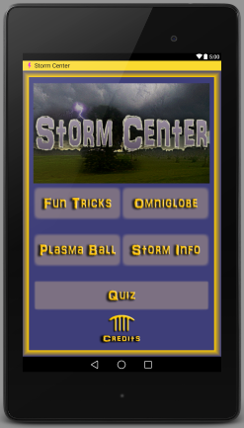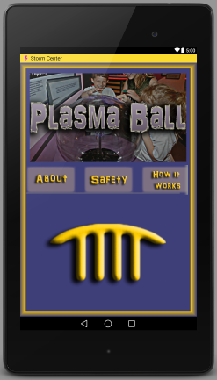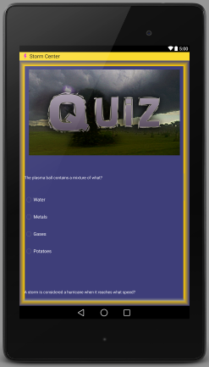

* + - Main page of Storm Center with five activities and two sub-activities
      * Fun Tricks
      * Omniglobe These activity buttons provide additional information
      * Plasma Ball and audio for the Storm Center exhibit. This helps
      * Storm Info enhance the visitor’s experience.
      * Quiz
        + This section is used to assess the visitors understanding of the Store Center.
      * Main MODS Page
        + The arches at the bottom of the main page connects back to the main MODS application.
      * Credits
        + This subdivision provides the customer with information about the creators of this app and who they thank for helping build it.

**Discussion**

Extensions that should be made to make this a complete app include:

* Integrating more audios form the museum’s exhibit panels
* Customizing the loading screen for the app
* Possibly customizing icons for the spaces where the museum icon is in the first four activities
* Connecting the activity bar and application more seamlessly
* Creating a more attractive credits pages
* Creating a Storm Center game like the exhibit has or possibly a different game
* Making the quiz more appealing with colorful pop-up dialogues of correct and incorrect answers, adding more questions, a final score, and the ability to scroll between questions
* Keeping dialogue boxes open when audio is clicked on
* Having the ability to turn off the audio once it has been played
* Making the webpage in the Storm info section have the ability to become full screen

**Conclusion**

We feel like we have accomplished a lot over the last three weeks. We learned a little more about Java, Graphics, and User Interface, but think we could have learned more and enjoyed the program more had it lasted longer. The ability to create a fully function application that looks good in just nine days was quite amazing to us. We are satisfied with the results of our application and hope to develop it further in the future. The app project folder can be found at the Github repository “StormCenter-App” or by going to <https://github.com/MODSApps/StormCenter-App>.

**Acknowledgements / Credits**

We would like to thank College Academy, Museum of Discovery and Science, Florida Atlantic University, United Way of Broward County, Joe Cytacki, and Summer Scarlatelli. We give credit to *Hello Android* by Ed Burnette, *Android for Programmers: An App-Driven Approach* by Paul Harvey and Abbey Deitel, and *Android Studio Essentials* by Neil Smyth, Dr. Ravi Shankar, Santiago Aguerrevere, Dr. Edwards, Osmar Coronel, and the websites Stack Overflow and Android Developers for helping with coding. We also give credit to Dr. McAfee and Demetrius for assistance with developing graphics.

**References**

* <http://www.ehow.com/how-does_4909971_plasma-ball-work.html>
* <http://wonderopolis.org/wonder/how-does-a-plasma-ball-work/>
* <http://www.nhc.noaa.gov/>
* <http://oceanservice.noaa.gov/facts/conveyor.html>
* <http://www.tropicalatlantic.com/ocean/>
* <http://modis.gsfc.nasa.gov>
* http://[www.ecowho.com/defn/c/carbon+flux/fff66](http://www.ecowho.com/defn/c/carbon+flux/fff66)
* <http://www.rockwellcollins.com/Services_and_Support/Information_Management/~/media/DA843DB0792946C58740F613328E5022.ashx>
* <https://solarsystem.nasa.gov/planets/profile.cfm?Object=Nep_Triton>
* <https://pixabay.com/en/wifi-wi-fi-wireless-web-internet-43872/>
* <https://upload.wikimedia.org/wikipedia/commons/6/69/Lightning_in_Arlington.jpg>
* <https://www.flickr.com/photos/jmd41280/3809552605>